Functional Design Document   
Track-IT Data Migration to Microsoft DevOps

|  |  |
| --- | --- |
| **Project:** | Global ERP Axapta Development |
| **Prepared for:** | Radiometer Medical ApS |
| **Prepared by:** | Jesper Ørbæk / Radiometer Medical ApS |
| **Date:** | 25 Sep 2021 |

Table of Contents

1 Introduction 3

1.1 Background information 3

1.2 Practical information and contact 3

1.3 Purpose of FDD 3

1.4 Privacy Information 3

2 Change History 4

3 Requirements 5

4 Prerequisites 6

5 Area of Functionality 7

5.1 Power Automate Flow and Excel add-in Functionality 7

5.2 Data mapping of fields between Track-It and DevOps 8

5.3 Data cleansing task as an outcome of data migration to DevOps 9

6 Other Aspects 9

7 Test description and execution 10

8 Abbreviations 10

**Table of Figures**

Figure 1: Change History 4

Figure 2: High-level Entity Relation Diagram of Track-It tables in scope 5

Figure 3: Work order example from Track-IT 6

Figure 4: Product Backlog Item example from Microsoft DevOps 8

Figure 5: Abbreviations 10

# Introduction

## Background information

Radiometer is currently storing development documentation on their AX installations (Microsoft Dynamics Axapta 2.5 and Microsoft Dynamics AX 209) in a non-validated system named Track-It, which has been delivered by the Norwegian Company InLead.

From the findings of a recent internal audit, Radiometer identified a non conformancy, which has resulted into that the documentation must be moved into a environment, which can be validated and controlled more properly than the existing one.

As Radiometer is planning to utilize Microsoft DevOps as part the implementation of Micrsooft D365 for Finance and Supply Chain Operations an obvious solution would be to all documentation going forward inside Microsoft DevOps in two separate projects: One for the old AX systems and one for the new D365 solution.

## Practical information and contact

Deadline for this is 120 calendar days starting to be counted from September 1st, 2021. That means that both the validation of the new solution and the data migration from the existing solution must be finished no later than December 20th, 2021 to meet this in due time.

The validation task is planned to be supported by external consultantants from Epista IT, while the support for data migration is expected to be supported by Nagarro Software. Contact and project responsible at Radiometer is: Jesper Ørbæk, ERP Application Development Manager, e-mail: [jesper.oerbaek@radiometer.dk](mailto:jesper.oerbaek@radiometer.dk), Phone: +45 2777 0924

## Purpose of FDD

The purpose of this functional design document (FDD) is to describe, how to support the solution of data migration of data stored within Track-IT into Microsoft DevOps.

The reason why this is needed is that Microsoft DevOps isn’t as system that open in order to import multiple notes (discussions) and attachments out of the box without establishing Power Automate Flows with some RestAPI integration included.

## Privacy Information

This document may contain customer information of a sensitive nature. This information should not be given to persons other than those who are involved with this system/project or who will become involved during its lifecycle.

# Change History

List changes made in the document and explain why the change has been made.

|  |  |  |  |
| --- | --- | --- | --- |
| Version | Date | Initials | Where and what - specification of changes |
| 1.0 | 25 Sep 2021 | JESOE | Initial version |
|  |  |  |  |
|  |  |  |  |
|  |  |  |  |

Figure 1: Change History

# Requirements

Data stored in Track-IT are located within the SQL server named \\DKRMED300 at Radiometer. The SQL Server holds multiple databases, but the one in scope is named “TrackIt80”.

The following three tables from this database are in scope:

1. Tasks – Containing meta data / attributes about each individual work order
2. TaskNote – Containing 1 to multiple notes per work order
3. Attachment – Containing 1 to multiple attachment per work order

As attachments can’t be stored inside the database each task has an associated file share, where all attachments in relation to the specific task is stored. The location of this file share is: \\dkrmed1057\WOAttach\

The relationship between the 3 tables and the external file share are illustrated in the following:

Dbo.task

note

Dbo.tasks

Dbo.

Attachment

\\DKRMED1057\WOAttach

Figure 2: High-level Entity Relation Diagram of Track-It tables in scope

Explained as:

* One-2-Many between tables tasks and tasknote through Tasks.WO_NUM = TaskNote.woid
* One-2-Many between tables tasks and attachment through Tasks.WO_NU= Attachment.AttachmentId
* One-2-One between table attachment and the fileshare. No. of attachments can be identified by cross checking with the value to Tasks.AttachCount

To extract tasks / work orders properly from TrackIt it must be done through the following two inquiries that needs to be established on the table ‘Tasks’ based on the task table:

1. Work orders where:
   1. field LookUp2 (also named ‘Status Info (AX)’) = “Closed (Released)” and
   2. WoType2 (also named ‘Sub category’) contains the text “Axapta”
2. Work orders where:
   1. field LookUp2 (also named ‘Status Info (AX)’) does not contain the text “Closed” and
   2. LookUp1 (also named ‘Status’) = “Request for Change” and
   3. WoType2 (also named ‘Sub category’) contains the text “Axapta”

The first inquiry will result in all work orders, which has been released / deployed for the existing AX instances, while the second inquiry will result in all open work orders / the backlog of development tasks. Due to the selection criteria of the LookUp2 field no duplicates work orders will be migrated.

The two inquiries have been established based on the diagnostic that has taken place by Radiometer during September 2021. The inquiries might be needed to refine in case they as an outcome of the functional test seems not to provide the correct information for the data migration to take place successfully.

For illustration purposes an example of open task/work order from the backlog has been included:

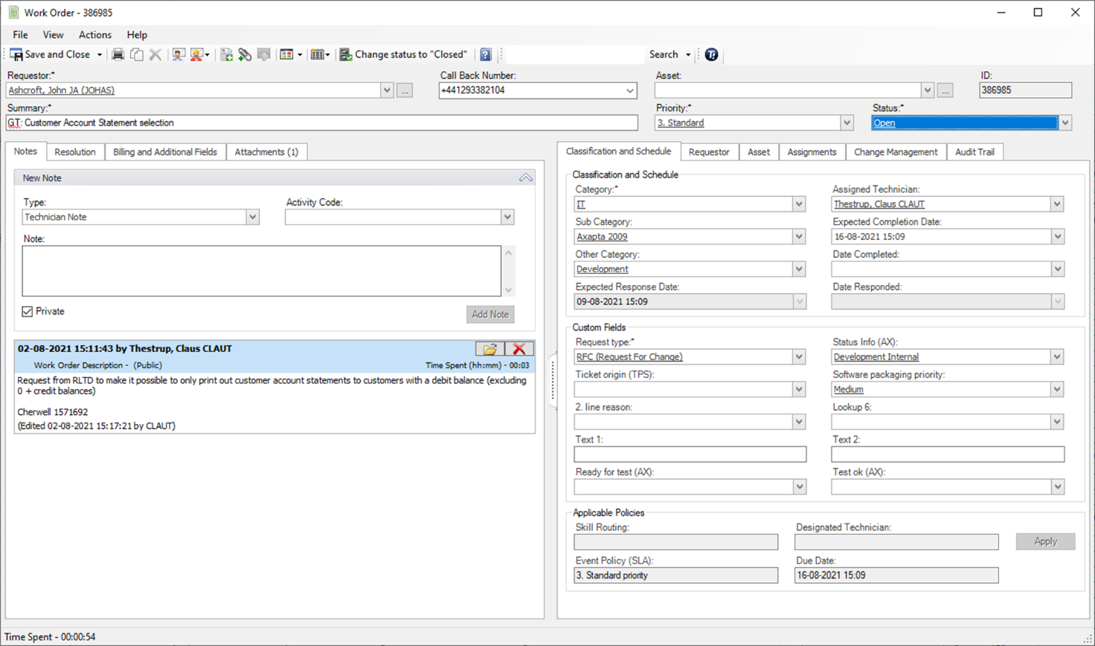

Figure 3: Work order example from Track-IT

# Prerequisites

To realize this FDD the user must have access at least to the following:

* Radiometer network through an associated Radiometer account
* Read user access rights for \\DKRMED300\TrackIt80
* Read user access rights for \\dkrmed1057\WOAttach\
* Full user access rights for the <https://dev.azure.com/RadiometerERP/Axapta_Development>
* Full user access rights for the <https://dev.azure.com/RadiometerGIT/Axapta_Development>

The DevOps project named ***Axapta_Development*** within the organization ***‘RadiometerERP’*** will be the ***TEST environment***, while the DevOps project named **Axapta_Development** within the organization **‘RadiometerGIT’** will be the **LIVE environment**

Further it might be necessary to establish user access to Track-IT through a technician account to document test results properly, however Track-IT is an old solution and is from time to time very unstable, when trying to access it remotely through VPN and the Radiometer network.

# Area of Functionality

This section described further details around, how data is going to be migrated from Track-IT to DevOps. However, if alternative and better solutions can be recommended Radiometer is open for suggestion taking time, complexity, and cost into consideration.

## Power Automate Flow and Excel add-in Functionality

The data migration is assumed to be possible to execute through the following standard tools available:

1. Microsoft Excel add-in extension for Microsoft DevOps
2. Power Automate flow

Ad. 1)

The migration of metadata / attributes on individual task in Track-IT is expected to take place through this Excel add-in to DevOps as it’s possible to extract data through an ODBC SQL Query into Excel and from their import them into Microsoft DevOps by using the add-in.

It is assumed that all work orders in Track-It can be migrated into Product Backlog Items within Microsoft DevOps, where the product back log item has been slightly reconfigured to compensate for additional information required by Radiometer. Radiometer will in relation to this facilitate the setup of DevOps processes to align with what is needed as external consultants will not be allowed to access this part of DevOps at Radiometer.

Ad. 2)

As Microsoft DevOps in not that open to import multiple notes and attachments to a specific work item in DevOps it is suggested to create two power automate flow that through REST API can execute this as illustrated in the following two videos’:

* Using Power Automate to add Comments in Azure DevOps: [Using Power Automate to Add Comments in Azure DevOps - YouTube](https://www.youtube.com/watch?v=gmmkm9kecV8)
* Using Power Automate to Attach files in Azure DevOps: [Using Power Automate to Attach files in Azure DevOps - YouTube](https://www.youtube.com/watch?v=WX9TU-6qJ3k)

As an example, the following setup of a product backlog item has been included in order to illustrate, how the future setup of the work items is going to look:

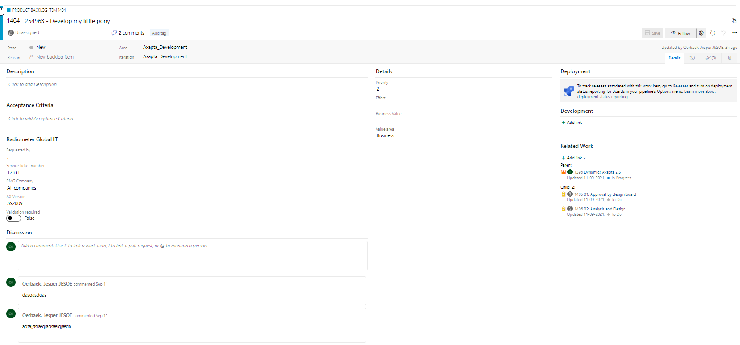

Figure 4: Product Backlog Item example from Microsoft DevOps

## Data mapping of fields between Track-It and DevOps

This section describes how data mapping between Track-It and DevOps is assumed to take place.

| Description in DevOps | Field name Track-IT | Field name / Value in DevOps |
| --- | --- | --- |
| Title | Concatenated key of Tasks.WO_NU + “: “ + Tasks.TASK | Title |
| Assigned person | Tasks.ClsdBy | Assigned – Value stays as unassigned in case person can’t be idenfitied |
| State | n/a | Fixed value = ?? |
| Reason | n/a | Reason |
| Area | n/a | Fixed value = ‘Axapa_Develpment’ |
| Iteration | n/a | Fixed value = ‘Axapa_Develpment’ |
| Description | Tasks.Descript | Description |
| Acceptance Criteria | n/a | Fixed value = <Blank> |
| Requested by | Tasks.Request | Requested by |
| Service Ticket number | Tasks.WO_NU | Service Ticket number |
| RMG Company | n/a | Fixed value = ‘All companies’ |
| AX Version | Tasks.WOType2 | If Tasks.WOType2 = ‘Axapta’ then Fixed value = “Axapta 2.5”  If Tasks.WOType2 = ‘Axapta 2.5’ then Fixed value = “Axapta 2.5”  If Tasks.WOType2 = ‘Axapta 2009’ then Fixed value = “Ax 2009” |
| Validation required | n/a | Fixed value = FALSE |
| Priority | n/a | Fixed value = 2 |
| Effort | n/a | Fixed value = 0 |
| Business value | n/a | Fixed value = <Blank> |
| Value area | n/a | Fixed value = ‘Business’ |

Changes to the above might appear, when the outcome of the first data migration is ready.

Besides the above mapping tables all notes in Track-It are assumed to be stored as individual discussions objects in DevOps ref. 2) in the previous section.

Similar attachment from the fileshare associated with track-it will be uploaded and all files per task will be attached to the product backlog item that will going forward represent the task in DevOps also with reference to 2) in the previous section.

## Data cleansing task as an outcome of data migration to DevOps

Because of the data migration to DevOps several data cleansing tasks might be defined. It has at the current stage not been possible to identify all of these, however, to establish a certain level of traceability it is necessary:

1. To relate each Product Backlog Item to a parent Feature expressing whether it is belonging to Axapta 2.5 or AX2009
2. To group Product Backlog Items into sprints defined as builds within Radiometer to track among other, when release / deployment took place

The data cleansing task regarding bullet 2) is a manual task, however it’s possible from the task notes to identify, which sprint/build the release/deployment took place. Further Radiometer has several release notes as well as an Excel sheet where parts of this also has been documented.

Further the field named Requested by within the Product Backlog Item should be migrated from a text field into an identity, however as it is not all the employees registered in Track-It that are employeed at Radiometer this might be challenging as their associated network account doesn’t exist anymore. Similar goes for the technician in Track-It will be migrated into the assigned person of the Product Backlog item.

Finally, for those Product Backlog Items that has been released / deployed ref. the query no. 1 defined in section 3 these must be associated with a specific area that prohibits the Product Backlog Items to be modified unless it’s specific users that does this. This task is expected to be managed by Radiometer as the logging / history of the Product Backlog Item must include traceability towards that this has been done by a Radiometer employee.

# Other Aspects

The functionality established as an outcome of this FDD will be deleted / removed from the Radiometer network as soon as the data migration has been successful completed, and the new Microsoft DevOps solution has proven its sustainability throughout the 1st quarter after go-live.

Taking the deadline defined ref. section 1.2 into consideration the removal is expected to take place ultimo March 2022, where also access to Track-IT will be decommissioned to secure that it’s no longer possible to store information in multiple available systems.

# Test description and execution

As a part of establishing the functionality described within this FDD test must be executed and documented showing data before and after that the migration has been executed.

The current solution holds around 3.200 work orders with associated multiple notes and multiple attachments. To document that the migration has been executed successfully a random test must be executed and documented that covers these outcomes

It has not yet been decided, how many random tests that might be needed, but it is expected to be in the range of 2-5%, which will be equally divided across Axapta 2.5 and AX 2009 work orders taking into consideration that there are workorders stored in Track-it since May 2011 until today.

In should be considered whether the documentation of test is worthwhile to establish with the use of RPA. In that case the RPA must be documented and tested separately as this needs to go in as enclosury to the documentation that will be established in co-operation with Epista IT.

# Abbreviations

|  |  |
| --- | --- |
| Abbreviation | Definition |
| Track-IT | Current non-validated solution holding all development documentation around all existing AX instances at Radiometer |
| DevOps | Future solution, which will hold two validated projects, where one of these will hold all development documentation around existing AX instances at Radiometer. |
|  |  |

Figure 5: Abbreviations